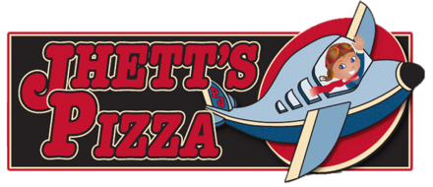

**Specialty Pizzas**

401 New York Ave. Holton, KS 66463 1+785-346-4944

Large 14” – Small 12” – Mega Mini 8” – Mini 6”

**Meat Lovers………….…$17.75 / $15.75 / $7.25 / $5.25**

Pepperoni, Canadian Bacon, Sausage, Hamburger, Italian Sausage

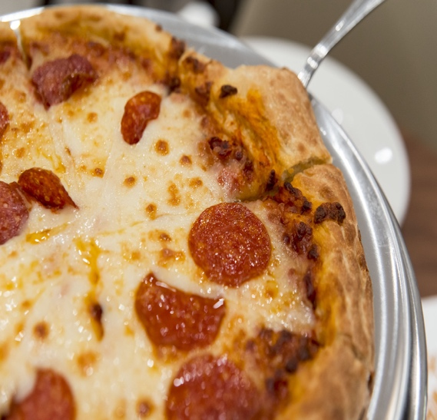

**RoadKill………………...$17.75 / $15.75 / $7.25 / $5.25**

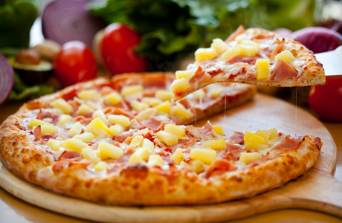

**Need Gluten Free?**

Gluten Free Crust: Only Size 10”…………$6.00

Seasoned or Non Seasoned

Add toppings for $0.50

**Additional Toppings: Items are $2.00 Each**

**Only $1.00 for 14” and 12”**

**Only $0.25 for 8” and 6”**

Start with our classic Cheese Pizza and choose from Red Sauce, Ranch or Alfredo.

**13.75 / $11.75 / $5.75 / $3.75**

**Build Your Own!**

Hamburger, Sausage, Pepperoni, Italian Sausage, Bacon, BBQ Beef, Canadian Bacon, Chicken, Onions, Tomatoes, Pineapple, Mushrooms, Green Peppers, Black Olives, Green Olives, Sauerkraut, Artichoke Hearts, Jalapenos, Banana Peppers, Buffalo*

Onions, Green Peppers, Black Olives and Mushrooms

Chicken tossed in Alfredo Sauce

Chicken tossed in Buffalo Sauce

Canadian Bacon with Pineapple

Spinach, Artichoke Cheese Dip, Artichoke Hearts, and Tomatoes with a Garlic Crust

Chicken, Onions, and Green Peppers

Chicken tossed in Ranch topped with Bacon

BBQ Beef and Chicken topped with Bacon

Pepperoni, Sausage, Hamburger, Onions, Mushrooms, Green Peppers, and Black Olives

**Supreme………………...$15.75 / $13.75 / $6.75 / $4.75**

**Buffalo Supreme……....$17.75 / $15.75 / $7.25/ $5.25**

Ground Buffalo, Onions, Green Peppers, Black Olives, and Mushrooms

**Bacon Cheeseburger….$15.75 / $13.75 / $6.75 / $4.75**

Hamburger and Onions topped with Bacon

**Toppings**

**Veggie Lovers..…….....$14.75 / $12.75 / $6.25 / $4.75**

**Chicken Alfredo..……..$14.75 / $12.75 / $6.25 / $4.75**

**Hawaiian……….……….$14.75 / $12.75 / $6.25 / $4.75**

**Buffalo Chicken..……..$14.75 / $12.75 / $6.25 / $4.75**

**Lady A…………………...$15.75 / $13.75 / $6.75 / $4.75**

**Chicken Bacon Ranch..$15.75 / $13.75 / $6.75 / $4.75**

**Chicken Fajita……..…..$15.75 / $13.75 / $6.75 / $4.75**

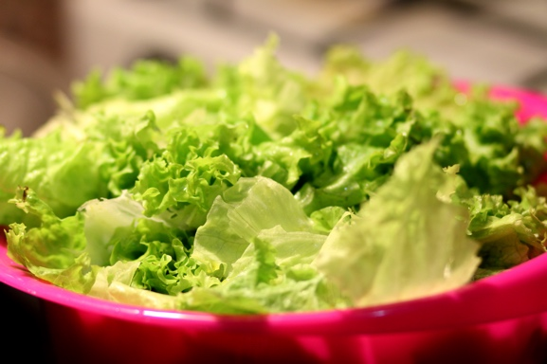

s

**Subs**

401 New York Ave. Holton, KS 66463 1+785-346-4944

**Drinks**

Soda/Tea.................................$2.00

Coffee/Hot Chocolate..............$0.75

Juice Box..................................$0.75

2 Liter (Pepsi or Diet Pepsi).....$2.50

To-Go Drink (32oz.).................$2.50

Mountain Dew (Can)................$1.00

**Extras**

Marinara Sauce….....$0.50

Ranch/Blue Cheese..$0.50

Alfredo.....................$0.50

**Served with Ranch, Marinara, or Blue Cheese**

Large 14” Small 12” Mega Mini 8” Mini 6”

Chicken and Pepperoni with Pizza Cheese, served with Lettuce and a side of Marinara Sauce

Chicken and Bacon with Pizza cheese, served with Lettuce and Chipotle Ranch Dressing

Served toasted on a 6” Hoagie Bun with Chips and a Pickle

Canadian Bacon, Cheddar Cheese, and Pizza Cheese, served with Lettuce and Mayonnaise.

Pepperoni and Canadian Bacon with Pizza cheese, served with lettuce and creamy Italian dressing

Served with your choice of dressing:

Ranch, Blue Cheese, Dorothy, Catalina, Olive Garden, Chipotle Ranch, Creamy Italian, Raspberry Vinaigrette

**Dinner Salad Large $4.00 Small $3.00**

**Jhett’s House Salad Large $5.75 Small $4.50**

**Chef Salad Large $5.75 Small $4.50**

**Holiday Salad Large $5.75 Small $4.50**

**Taco Salad Large $6.00**

**Chicken Fajita Large $6.00**

**Chicken and Pepperoni Sub……..$6.00**

**Stick & Wings**

**Salads**

**Italian Sub……………………….….$6.00**

**Hot Ham & Cheese………………...$6.00**

**Chicken Bacon Chipotle Sub…….$6.00**

116 West 4th St. Hoyt, KS 66440 *1+785-986.1000*

**Bread Stick……………....$8.75 / $6.75 / $4.75/ $2.75**

**Garlic Stick……….........$8.75 / $6.75 / $4.75 / $2.75**

**Extra Toppings ………….$1.50 / $1.00 $0.25**

**Hot Wings ………………. 12/$9.00 8/$6.00 4/$3.00**

**Cinnamon Stick Only Size 10” $5.50**